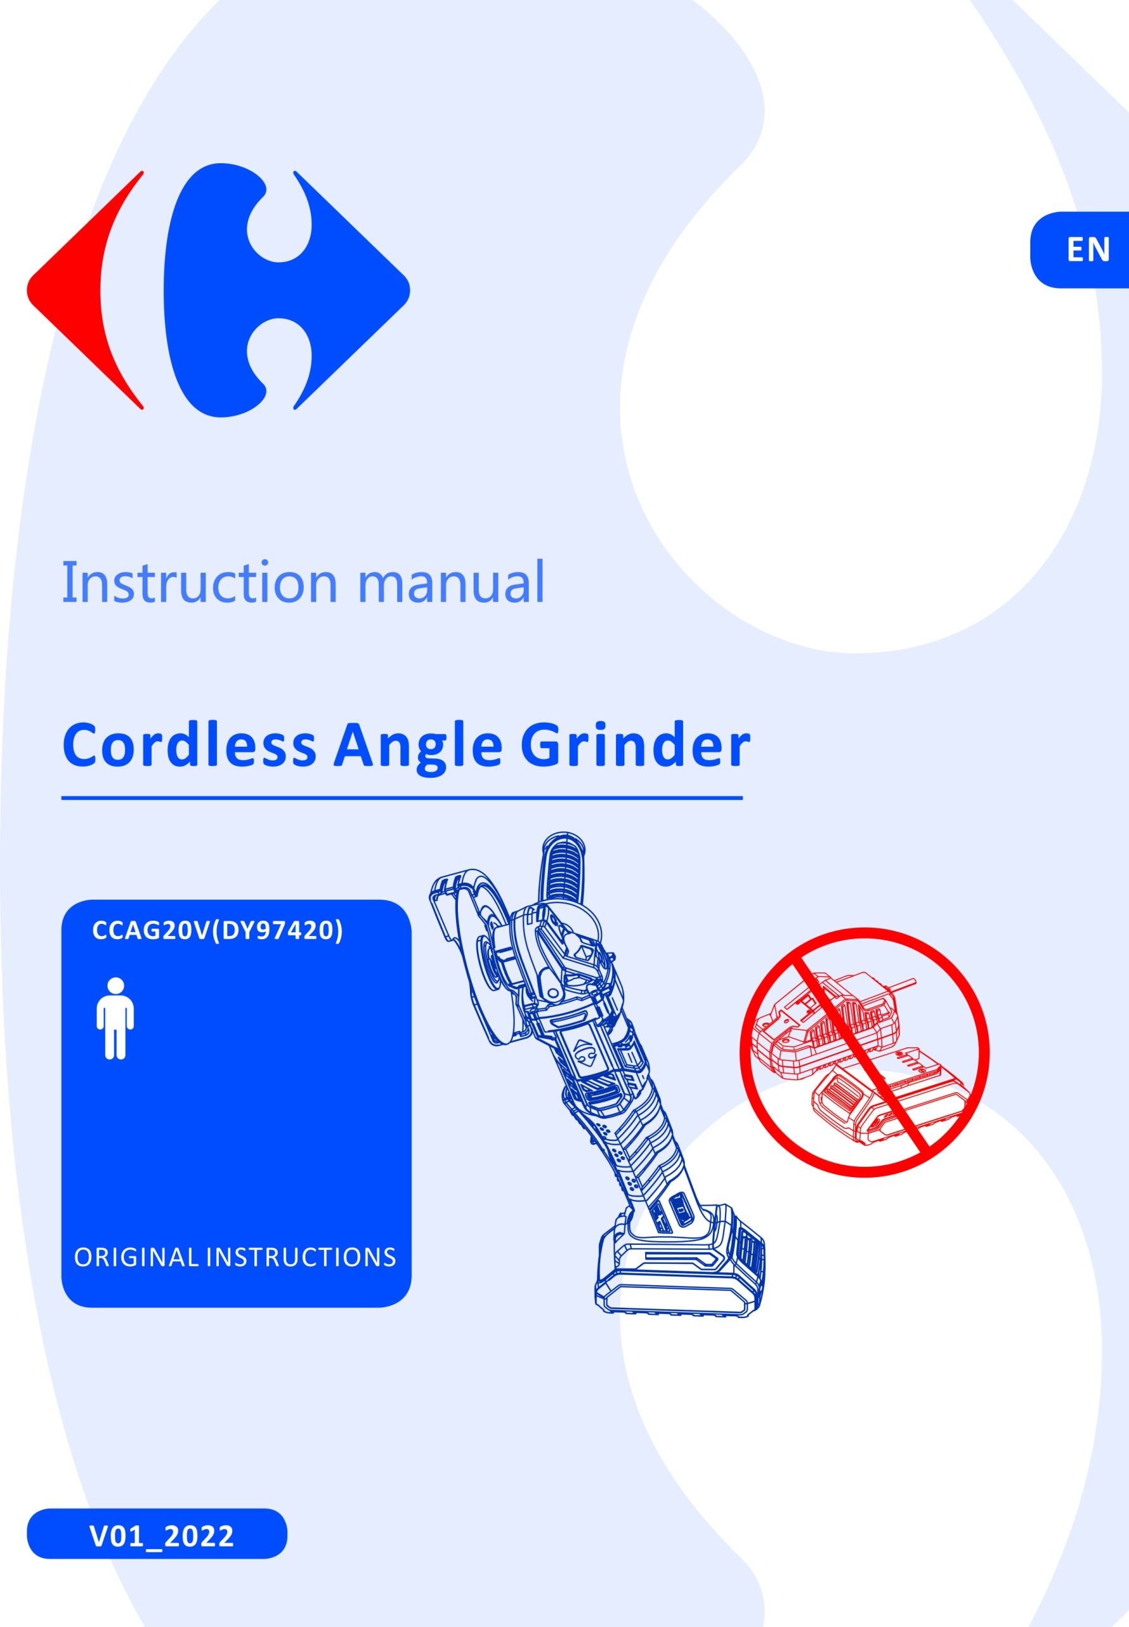



|  |
| --- |
| **Congratulation on your purchase.**  **The quality team at CARREFOUR cares for its products to meet conformity and performances.**  **Paying close attention to your satisfaction, our experts work all day on the improvement of our products.** |



|  |
| --- |
| For assembly and/or maintenance and/or use of your product, you can use:  F:\2016-2019 订单资料\BULL\Caffefour IM chart\1_pictograms\hammer.jpg F:\2016-2019 订单资料\BULL\Caffefour IM chart\1_pictograms\screwdriver_001.jpg  These products are available in CARREFOUR stores. |



|  |
| --- |
| For a better use of your new device, we recommend you to read carefully this Instruction Manual and keep it for record.  Keep it carefully for future reference.  Please also find information about the scraping of the product in this Instruction Manual. |



|  |
| --- |
| Before installing or using the product, please read carefully the safety measures after the  summary. |

**Pictograms used**

|  |  |
| --- | --- |
| F:\2016-2019 订单资料\BULL\Caffefour IM chart\1_pictograms\danger.jpg | Warning symbols with information on damage and injury prevention. |
|  | Read the operation instructions carefully. |
| F:\2016-2019 订单资料\BULL\Caffefour IM chart\1_pictograms\WEEE icon.jpg | Electrical products must not be disposed of with the domestic waste. |
|  | Wear hearing protection. |
|  | Wear safety glasses. |
|  | Battery & charger not included in box. |

**CONTENTS**

[SAFETY INSTRUCTIONS 4](#_Toc77930912)

[PRODUCT DESCRIPTION 10](#_Toc77930931)

[INTENDED USE 13](#_Toc77930933)

[BEFORE USE 13](#_Toc77930934)

[OPERATION 16](#_Toc77930935)

[CLEANING & MAINTENANCE 17](#_Toc77930936)

[STORAGE AND TRANSPORTATION 17](#_Toc77930937)

[REPLACEMENT PARTS /ACCESSORIES 17](#_Toc77930938)

[TROUBLESHOOTING 18](#_Toc77930939)

[DISPOSAL 18](#_Toc77930940)

[DECLARATION OF CONFORMITY 19](#_Toc77930941)

[WARRANTY 20](#_Toc77930942)

[PRODUCT FAILURE 21](#_Toc77930943)

[WARRANTY EXCLUSIONS 22](#_Toc77930944)

## SAFETY INSTRUCTIONS

### GENERAL POWER TOOL SAFETY WARNINGS

**WARNING Read all safety warnings, instructions, illustrations and specifications provided with this power tool.** *Failure to follow all instructions listed below may result in electric shock, fire and/or serious injury*.

### Save all warnings and instructions for future reference.

*The term "power tool" in the warnings refers to your mains-operated (corded) power tool or battery-operated (cordless) power tool.*

### Work area safety

* 1. **Keep work area clean and well lit**. *Cluttered or dark areas invite accidents.*
  2. **Do not operate power tools in explosive atmospheres, such as in the presence of flammable liquids, gases or dust.** *Power tools create sparks which may ignite the dust or fumes.*
  3. **Keep children and bystanders away while operating a power tool.** *Distractions can cause you to lose control.*

### Electrical safety

* 1. **Power tool plugs must match the outlet. Never modify the plug in any way. Do not use any adapter plugs with earthed (grounded) power tools.** *Unmodified plugs and matching outlets will reduce risk of electric shock.*
  2. **Avoid body contact with earthed or grounded surfaces, such as pipes, radiators, ranges and refrigerators.** *There is an increased risk of electric shock if your body is earthed or grounded.*
  3. **Do not expose power tools to rain or wet conditions.** *Water entering a power tool will increase the risk of electric shock.*
  4. **Do not abuse the cord. Never use the cord for carrying, pulling or unplugging the power tool. Keep cord away from heat, oil, sharp edges or moving parts.** *Damaged or entangled cords increase the risk of electric shock.*
  5. **When operating a power tool outdoors, use an extension cord suitable for outdoor use.** *Use of a cord suitable for outdoor use reduces the risk of electric shock.*
  6. **If operating a power tool in a damp location is unavoidable, use a residual current device (RCD) protected supply.** *Use of an RCD reduces the risk of electric shock.*

### Personal safety

* 1. **Stay alert, watch what you are doing and use common sense when operating a power tool. Do not use a power tool while you are tired or under the influence of drugs, alcohol or medication.** *A moment of inattention while operating power tools may result in serious personal injury.*
  2. **Use personal protective equipment. Always wear eye protection.** *Protective equipment such as a dust mask, non-skid safety shoes, hard hat or hearing protection used for appropriate conditions will reduce personal injuries.*
  3. **Prevent unintentional starting. Ensure the switch is in the off-position before connecting to power source and/or battery pack, picking up or carrying the tool.** *Carrying power tools with your finger on the switch or energising power tools that have the switch on invites accidents.*
  4. **Remove any adjusting key or wrench before turning the power tool on.** *A wrench or a key left attached to a rotating part of the power tool may result in personal injury.*
  5. **Do not overreach. Keep proper footing and balance at all times.** *This enables better control of the power tool in unexpected situations.*
  6. **Dress properly. Do not wear loose clothing or jewellery. Keep your hair and clothing away from moving parts.** *Loose clothes, jewellery or long hair can be caught in moving parts.*
  7. **If devices are provided for the connection of dust extraction and collection facilities, ensure these are connected and properly used.** *Use of dust collection can reduce dust-related hazards*.

### Power tool use and care

* 1. **Do not force the power tool. Use the correct power tool for your application.** *The correct power tool will do the job better and safer at the rate for which it was designed.*
  2. **Do not use the power tool if the switch does not turn it on and off.** *Any power tool that cannot be controlled with the switch is dangerous and must be repaired.*
  3. **Disconnect the plug from the power source and/or remove the battery pack, if detachable, from the power tool before making any adjustments, changing accessories, or storing power tools.** *Such preventive safety measures reduce the risk of starting the power tool accidentally.*
  4. **Store idle power tools out of the reach of children and do not allow persons unfamiliar with the power tool or these instructions to operate the power tool.** *Power tools are dangerous in the hands of untrained users.*
  5. **Maintain power tools and accessories. Check for misalignment or binding of moving parts, breakage of parts and any other condition that may affect the power tool’s operation. If damaged, have the power tool repaired before use.** *Many accidents are caused by poorly maintained power tools.*
  6. **Keep cutting tools sharp and clean.** *Properly maintained cutting tools with sharp cutting edges are less likely to bind and are easier to control.*
  7. **Use the power tool, accessories and tool bits etc. in accordance with these instructions, taking into account the working conditions and the work to be performed.** *Use of the power tool for operations different from those intended could result in a hazardous situation.*

### Battery tool use and care

* 1. **Recharge only with the charger specified by the manufacturer**. *A charger that is suitable for one type of battery pack may create a risk of fire when used with another battery pack.*
  2. **Use power tools only with specifically designated battery packs.** *Use of any other battery packs may create a risk of injury and fire.*
  3. **When battery pack is not in use, keep it away from other metal objects, like paper clips, coins, keys, nails, screws or other small metal objects, that can make a connection from one terminal to another**. *Shorting the battery terminals together may cause burns or a fire.*
  4. **Under abusive conditions, liquid may be ejected from the battery; avoid contact. If contact accidentally occurs, flush with water. If liquid contacts eyes, additionally seek medical help**. *Liquid ejected from the battery may cause irritation or burns.*

### Service

* 1. **Have your power tool serviced by a qualified repair person using only identical replacement parts.**

*This will ensure that the safety of the power tool is maintained.*

### Safety instructions for all operations

**Safety Warnings Common for Grinding, Sanding, Wire Brushing, Polishing or Abrasive Cutting-Off Operations**

1. **This power tool is intended to function as a grinder or cut-off tool. Read all safety warnings, instructions, illustrations and specifications provided with this power tool.** *Failure to follow all instructions listed below may result in electric shock, fire and/or serious injury.*
2. **Operations such as sanding, wire brushing, polishing are not to be performed with this power tool**. *Operations for which the**power tool was not designed may create a hazard and cause personal injury*.
3. **Do not use accessories which are not specifically designed and specified by the tool manufacturer**. *Just because the accessory can be attached to your power tool, it does not assure safe operation*.
4. **The rated speed of the accessory must be at least equal to the maximum speed marked on the power tool**. *Accessories running faster than their rated speed can break and fly apart.*
5. **The outside diameter and the thickness of your accessory must be within the capacity rating of your power tool**. *Incorrectly sized accessories cannot be adequately guarded or controlled.*
6. **Threaded mounting of accessories must match the grinder spindle thread. For accessories mounted by flanges, the arbour hole of the accessory must fit the locating diameter of the flange.** *Accessories that do not match the mounting hardware of the power tool will run out of balance, vibrate excessively and may cause loss of control.*
7. **Do not use a damaged accessory. Before each use inspect the accessory such as abrasive wheels for chips and cracks, backing pad for cracks, tear or excess wear, wire brush for loose or cracked wires. If power tool or accessory is dropped, inspect for damage or install an undamaged accessory. After inspecting and installing an accessory, position yourself and bystanders away from the plane of the rotating accessory and run the power tool at maximum no-load speed for one minute.** *Damaged accessories will normally break apart during this test time*.
8. **Wear personal protective equipment. Depending on application, use face shield, safety goggles or safety glasses. As appropriate, wear dust mask, hearing protectors, gloves and workshop apron capable of stopping small abrasive or workpiece fragments**. *The eye protection must be capable of stopping flying debris generated by various applications. The dust mask or respirator must be capable of filtrating particles generated by the particular application. Prolonged exposure to high intensity noise may cause hearing loss*.
9. **Keep bystanders a safe distance away from work area. Anyone entering the work area must wear personal protective equipment**. *Fragments of workpiece or of a broken**accessory may fly away and cause injury beyond immediate area of operation*.
10. **Hold the power tool by insulated gripping surfaces only, when performing an operation where the cutting accessory may contact hidden wiring or its own cord.** *Cutting accessory contacting a "live" wire may make exposed metal parts of the power tool**"live" and could give the operator an electric shock*.
11. **Position the cord clear of the spinning accessory**. *If you lose control, the cord may be cut or snagged and your hand or arm may be pulled into the spinning accessory*.
12. **Never lay the power tool down until the accessory has come to a complete stop**. *The spinning accessory may grab the surface and pull the power tool out of your control.*
13. **Do not run the power tool while carrying it at your side**. *Accidental contact with the spinning accessory could snag your clothing, pulling the accessory into your body*.
14. **Regularly clean the power tool’s air vents**. *The motor’s fan will draw the dust inside the housing and excessive accumulation of powdered metal may cause electrical hazards*.
15. **Do not operate the power tool near flammable materials.** *Sparks could ignite these materials*.
16. **Do not use accessories that require liquid coolants.** *Using water or other liquid coolants may result in electrocution or shock*.

### Further safety instructions for all operations

**Kickback and Related Warnings**

Kickback is a sudden reaction to a pinched or snagged rotating wheel, backing pad, brush or any other accessory. Pinching or snagging causes rapid stalling of the rotating accessory which in turn causes the uncontrolled power tool to be forced in the direction opposite of the accessory’s rotation at the point of the binding.

For example, if an abrasive wheel is snagged or pinched by the workpiece, the edge of the wheel that is entering into the pinch point can dig into the surface of the material causing the wheel to climb out or kick out. The wheel may either jump toward or away from the operator, depending on direction of the wheel’s movement at the point of pinching. Abrasive wheels may also break under these conditions.

Kickback is the result of power tool misuse and/or incorrect operating procedures or conditions and can be avoided by taking proper precautions as given below.

1. **Maintain a firm grip on the power tool and position your body and arm to allow you to resist kickback forces. Always use auxiliary handle, if provided, for maximum control over kickback or torque reaction during start-up.** *The operator can control torque reactions or kickback forces, if proper precautions are taken.*
2. **Never place your hand near the rotating accessory.** *Accessory may kickback over your hand.*
3. **Do not position your body in the area where power tool will move if kickback occurs.** *Kickback will propel the tool in direction opposite to the wheel’s movement at the point of snagging.*
4. **Use special care when working corners, sharp edges etc.** **Avoid bouncing and snagging the accessory.** *Corners, sharp edges or bouncing have a tendency to snag the rotating accessory and cause loss of control or kickback.*
5. **Do not attach a saw chain woodcarving blade, segmented diamond wheel with a peripheral gap greater than 10mm or toothed saw blade.** *Such blades create frequent kickback and loss of control.*

### Additional safety instructions for grinding and cutting-off operations

### Safety Warnings Specific for Grinding and Abrasive Cutting-Off Operation

1. **Use only wheel types that are specified for your power tool and the specific guard designed for the selected wheel.** *Wheels for which the power tool was not designed cannot be adequately guarded and are unsafe.*
2. **The grinding surface of centre depressed wheels must be mounted below the plane of the guard lip.** *An improperly mounted wheel that projects through the plane of the**guard lip cannot be adequately protected.*
3. **The guard must be securely attached to the power tool and positioned for maximum safety, so the least amount of wheel is exposed towards the operator.** *The guard**helps to protect the operator from broken wheel fragments, accidental contact with wheel**and sparks that could ignite clothing.*
4. **Wheels must be used only for specified applications. For example: do not grind with the side of cut-off wheel.** *Abrasive cut-off wheels are intended for peripheral grinding, side forces applied to these wheels may cause them to shatter.*
5. **Always use undamaged wheel flanges that are of correct size and shape for your selected wheel.** *Proper wheel flanges support the wheel thus reducing the possibility of**wheel breakage. Flanges for cut-off wheels may be different from grinding wheel flanges*.
6. **Do not use worn down wheels from larger power tools.** *A wheel intended for larger**power tool is not suitable for the higher speed of a smaller tool and may burst.*

### Additional safety warnings specific for grinding and cutting-off operations:

**Additional Safety Warnings Specific for Abrasive Cutting-Off Operations**

1. **Do not “jam” the cut-off wheel or apply excessive pressure. Do not attempt to make an excessive depth of cut.** *Overstressing the wheel increases the loading and susceptibility to twisting or binding of the wheel in the cut and the possibility of kickback or wheel breakage.*
2. **Do not position your body in line with and behind the rotating wheel.** *When the wheel, at the point of operation, is moving away from your body, the possible kickback**may propel the spinning wheel and the power tool directly at you.*
3. **When the wheel is binding or when interrupting a cut for any reason, switch off the power tool and hold it motionless until the wheel comes to a complete stop. Never attempt to remove the cut-off wheel from the cut while the wheel is in motion otherwise kickback may occur.** *Investigate and take corrective action to eliminate the**cause of wheel binding.*
4. **Do not restart the cutting operation in the workpiece. Let the wheel reach full speed and carefully re-enter the cut.** *The wheel may bind, walk up or kickback if the power tool**is restarted in the workpiece.*
5. **Support panels or any oversized workpiece to minimize the risk of wheel pinching and kickback.** *Large workpieces tend to sag under their own weight. Supports must be**placed under the workpiece near the line of cut and near the edge of the workpiece on**both sides of the wheel.*
6. **Use extra caution when making a “pocket cut” into existing walls or other blind areas.** *The protruding wheel may cut gas or water pipes, electrical wiring or objects that**can cause kickback.*

### Specific safety instructions for angle grinder

1. When using a cut-off abrasive wheel guard for facial grinding, the wheel guard may interfere with the workpiece causing poor control.
2. When using a grinding wheel guard for cutting-off operating with the bonded abrasive wheels, there is an increased risk of exposure to emitted sparks and particles, as well as exposure to wheel fragments in the events of wheel burst.
3. Only use the abrasive wheels which are recommended in this manual.

### Special safety instructions for battery-operated tools

1. **Ensure that the tool is switched off before inserting the battery.** Inserting a battery into a tool that is switched on may result in accidents.
2. **Recharge the batteries indoors only because the battery charger is designed for indoor use only**. Risk of electric shock.
3. **To reduce the electric shock hazard, unplug the battery charger from the mains before cleaning the charger**.
4. **Do not subject the battery to strong sunlight over long periods and do not leave it on a heater.** Heat damages the battery and this is risk of explosion.
5. **Allow a hot battery to cool before charging**.
6. **Do not open up the battery and avoid mechanical damage to the battery. Risk of short circuit and fumes may be emitted that irritate the respiratory tract.** Ensure fresh air and seek medical assistance in the event of discomfort.
7. **Do not use non-rechargeable battery.** This could damage the appliance.
8. **The recommended ambient temperature range for the charging system during charging is from 4ºC to 40 ºC**.
9. **The recommended ambient temperature range for tool and battery storage is from 0ºC to 50 ºC**.
10. **The recommended ambient temperature range for tool and battery use is from -5ºC to 50 ºC**.
11. **Remove the battery from the device before storage.**
12. **Electrolyte leaking from the cells can cause damage to the skin, clothes or any other items exposed to it. If the electrolyte contacts the skin or clothes, wash thoroughly with clean water. If the electrolyte enters into the eyes, do not rub the eyes but flush them immediately with copious amounts of clean water such as tap water, and immediately consult a doctor.**
13. **Do not disassemble or modify the battery, which can cause short-circuiting between cells or between the cell and its wiring, and disables the battery’s safety protection system. These can lead to electrolyte leakage, overheating or a cell or battery, bursting and fire.**
14. **Avoid casual or inadvertent shorting of a battery with metallic objects such as: wire, tools, neckless or hairpins, which can cause short-circuiting, which cause excess current flow, electrolyte leakage, heating of cells or batteries, bursting and fire.**
15. **Keep battery away from a fire or heat. The insulation materials will melt and the gas release vent and protection system will be damaged, causing electrolyte leakage, bursting and possibly fire.**
16. **Not allow the battery to contact with water or gets wet, it may short-circuit, overheat, rust or lose its functions.**
17. **Do not expose the battery to mechanical shock, for example, by dropping, throwing or crushing, causing electrolyte leakage, cell and battery heating, bursting and fire.**
18. **Avoid the battery to directly connect to electric source such as a car lighter socket, or car battery, which may cause excess current to flow at high voltage and can cause electrolyte leakage, overheating of a cell or battery, bursting and fire.**

### Vibration and noise reduction

To reduce the noise and vibration emission, limit the time of operation, use low-vibration and low noise operating modes as well as wear personal protective equipment.

Take the following points into account to minimize the vibration and noise exposure risks:

* Only use the product as intended by its design and these instructions
* Ensure that the product is in good condition and well maintained
* Use correct attachments for the product and ensure they are in good condition
* Keep tight grip on the handles surface
* Plan your work schedule to spread any high vibration tool use across a longer period of time.

### Residual Risk

Even if properly operating and handling this product in accordance with all the safety requirements, potential risks of injury and damage remain. Due to its construction and build, this tool may present the following hazards:

1. There is risk of a short-circuit due to liquids penetrating the housing. Do not immerse the product and the accessories in water. Make sure that no water or other liquids can enter the housing.
2. Ear damage or hearing loss if working without ear protection
3. The harmful /toxic dusts produced during operation pose the risk to the health of the operator and persons in the vicinity. Wear eye protection and a dust mask.
4. Keep a sufficient distance from heat sources.
5. The appliance is not a toy and does not belong in the hands of children.

## PRODUCT DESCRIPTION

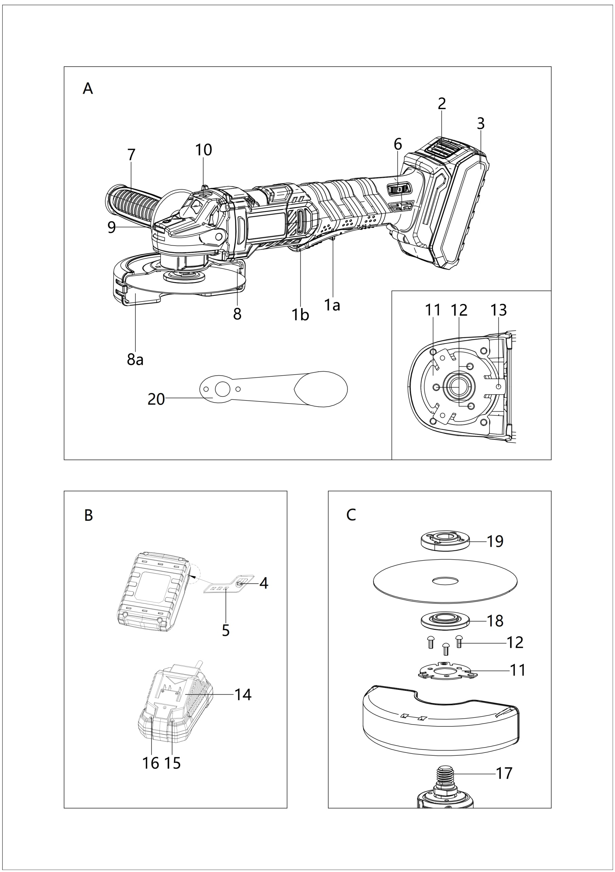

\*Battery & charger not included in box

(Fig. A)

**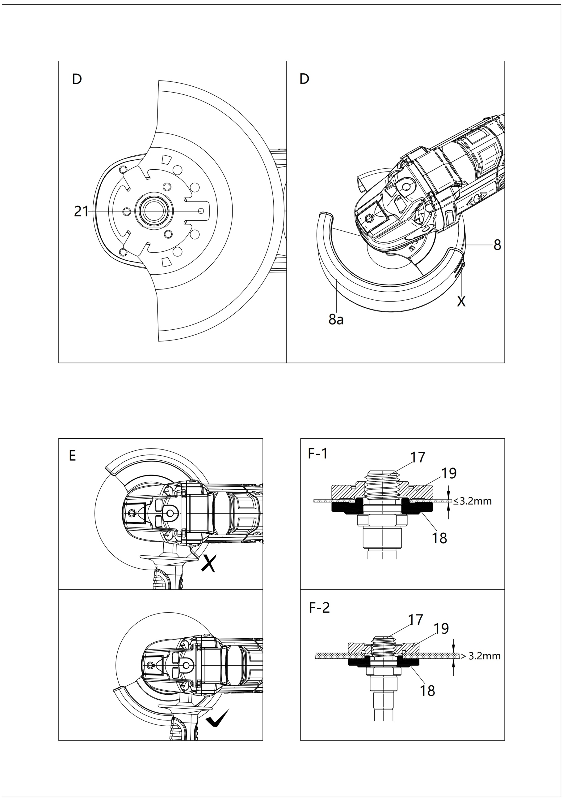**

### Overview (Fig. A-C)

1a. lock-off device

1b. ON/OFF switch button

1. Battery release button
2. Battery pack
3. Battery charge level button
4. Battery level indication (LED)
5. Speed setting wheel
6. Additional handle
7. Guard

8a. protective cover for cut-off wheel

1. Spindle locking button
2. Screw thread (3x) for the additional handle
3. Mounting ring
4. Screws
5. Guard fixture
6. Charger
7. RED Charge control LED
8. GREEN charge control LED
9. Attachment spindle
10. Attachment flange
11. Clamping nut
12. Two-hole mounting spanner
13. Bugles

**Introduction**

The operating instructions contain important information on safety, use and disposal. It is essential that you read the instructions before assembling, operation and maintaining the product. Use the product only as described and for the applications specified. Keep this manual safely and in the event that the product is passed on, hand over all documents to the third party.

**Technical data**

|  |  |  |
| --- | --- | --- |
| Rated voltage | 20V d.c. | |
| Rated speed n | 2500-10000/min | |
| Spindle thread | M14 | |
| Max. Disc diameter | Φ125mm | |
| Weight (without charger) | 1.7kg | |
| **Battery pack** (\*Not included in box) | **CBA20V2A** | CBA20V4 |
| Type | Li-ion | Li-ion |
| Rated voltage | 20V d.c. | 20V d.c. |
| Capacity | 2.0Ah (40Wh) | 4.0Ah (80Wh) |
| **Battery charger** (\*Not included in box) | **CCH20V** | |
| Rated input | 230-240V~, 50Hz | |
| Rated input Power | 65W | |
| Rated output | 21.5V d.c. | |
| Charging current | 2.4A | |
| Charging time | Approx. 60min for 2Ah battery, 120min for 4Ah battery | |
| Protection class | II | |
| **Noise emission value** |  | |
| Noise measurement value determined in accordance with EN 60745-2-3 | | |
| LPA | 79.7dB(A) | |
| Uncertainty K | 3dB(A) | |
| LWA | 90.7dB(A) | |
| Uncertainty K | 3dB(A) | |
| **Vibration emission value** |  | |
| Vibration value determined in accordance with EN 60745-2-3 | | |
| ah,D | 8.087 m/s2 | |
| Uncertainty K | 1.5 m/s2 | |

* The declared vibration total values and the declared noise emission values have been measured in accordance with a standard test method and may be used for comparing one tool with another.
* The declared vibration total values and the declared noise emission values may also be used in a preliminary assessment of exposure.

**WARNINGS**

* The vibration and noise emissions during actual use of the power tool can differ from the declared values depending on the ways in which the tool is used especially what kind of workpiece is processed; and
* It is necessary to identify safety measures to protect the operator that are based on an estimation of exposure in the actual conditions of use (taking account of all parts of the operating cycle such as the times when the tool is switched off and when it is running idle in addition to the trigger time)

## INTENDED USE

This product is intended for cutting, rough cutting and brushing metal, concrete or tiles without the use of water.

Any other uses or modification to the appliance is deemed to be improper usage and may result in serious physical injury. The manufacturer accepts no responsibility for damage(s) attributable to misuse. This product is designed for use by adults and not intended for commercial use.

## BEFORE USE

**Unpacking**

1. Unpack all parts and lay them on a flat stable surface
2. Make sure the delivery contents are complete and free of damage. If you find that parts are missing or show damage, do not use the product but contact your dealer/service centre. Do not use the product unless missing parts have been delivered in addition or defective parts have been replaced. Using an incomplete or damaged product represents a hazard to people and property.
3. Ensure that you have all the accessories and tools needed for assembly and operation.

**Scope of the delivery**

Carefully unpack the cordless drill and check that it is complete:

* 1 x Battery-operated cordless angle grinder
* 1 x cutting disc (pre-assembled)
* 1 x guard (pre-assembled)
* 1 x additional handle
* 1 x two-hole mounting spanner
* 1 x transport case
* 1 x Instruction manual

**Charging the battery pack (Fig. B)**

**Note:**

* **The battery can be damaged in case of improper charging.**
* **Remove the charger's mains plug before inserting or removing the battery.**

The battery is partially charged upon delivery to avoid damage to the battery caused by a deep discharge. Prior to initial start-up and when the battery is low, the battery should be charged. To do so, please proceed as follows (Fig. B):

1. Slide the battery pack (3) onto the charger (14) upside down till it locks in place.
2. Insert the mains plug of the charger (17) into a properly fused mains socket. The RED charge control LED (15) is illuminated; and charging requires approx. 60min.
3. Wait until the RED charge control LED (15) goes out and green charge control LED (16) is illuminated, the battery is fully charged.
4. Hold onto the mains plug while pulling the power cable of the charger out of the mains socket. The battery pack (3) and the charger (14) may have become warm during charging, allow the battery to cool down to room temperature.
5. Take the battery (3) out of the charger (14) by pressing and holding the battery release button (2) and pulling the battery pack (3) out of the charger (14).

**Removing /Inserting the battery**

1. Slide the battery pack (3), place it on a guide track and push it back into the battery holder. It will audibly snap in.
2. Detach the battery pack (14) from the tool, press the battery release button (2) on the battery pack (3) and pull the battery off the tool.

**Checking the battery charging level**

The battery comes with an integrated battery level indication.

The battery status is displayed as follows by the three LEDs of the battery level indication (LED) (5).

|  |  |
| --- | --- |
| **LED color** | **Meaning** |
| Green-Orange-Red | Maximum charge/power |
| Orange-Red | Medium charge / power |
| Red | Weak charge – Recharge the battery |

Press on the battery charge level button (4) on the battery pack (3). You can read the battery status from the battery level indication (LED) (5).

**Fitting the protective cover for cutting**

When cutting with the cut-off abrasive wheel, always use the protective cover (8a) for cutting.

1. Slide the protective cover (8a) onto the guard (8) (see Fig. D) until the plastic clip “X” snaps into place at the end.
2. When removing the protective cover (8a), press the plastic clip “X” in slightly to release the protective cover (8a)

**Adjusting the wheel guard**

**WARNING! Remove the battery pack before carrying out any work!**

1. Turn the guard (8) to the required position (working position). Make sure that the guard (8) is positioned in such a way that the guard fixture (13) lies over one of the 5 bulges (21) on the guard (8).
2. Ensure that the guard fixture (13) is firmly seated in the respective bulge (21).

**WARNING! RISK of INJURY!**

* Always use the angle grinder with the guard (8). The guard should be installed securely. Set it so that the highest possible degree of safety is achieved, i.e. the smallest possible part of the grinding disc is exposed to the operator. The guard is designed to protect the operator from fragments and accidental contact with the grinding tool.
* Make sure that the guard (8) is fitted at least the same angle as the additional handle (7) (see. Fig. E) otherwise you could injure yourself on the roughing disc or cutting disc.

**Fitting the additional handle**

**WARNING! For safety reason, the angle grinder must only be used with the additional handle. Failure to do so can lead to serious injury.**

Screw the additional handle (7) onto the left, right or the top, depending on the job at hand.

**Fitting /changing the grinding/cutting disc**

**WARNING! Always wear the protective gloves when changing the grinding/cutting disc.**

Press the spindle locking button (9) to lock the shaft.

Undo the clamping nut (19) with the two-hole mounting spanner (20) (see Fig. F).

Place the grinding or cutting disc with the label side towards the angle grinder on the attachment flange (18)

Then replace the clamping nut (19) on the attachment spindle (17) with the raised side facing up.

* 1. **With thin discs (Fig.F-1)**
* The collar of the clamping nut (19) faces upwards so that a thin disc can be fitted safely.
* Press the spindle locking button (9) to lock the attachment spindle (17).
* Tighten the clamping nut (19) with the two-hole mounting spanner (20).
  1. **With thick discs (Fig F-2)**
* The collar of the clamping nut (19) faces downwards so that a thin disc can be fitted securely onto the attachment spindle (17).
* Press the spindle locking button (9) to lock the attachment spindle (17).
* Tighten the clamping nut (19) with the two-hole mounting spanner (20).

**Note:**

* **Use only discs which are free of dirt.**
* **Use only grinding disc whose permissible speed rating is at least as high as that on the rating label of the angle grinder.**
* **RISK of INJURY! Press the spindle locking button (9) only when the attachment spindle (17) is at a complete standstill.**
* **If the disc does not turn smoothly or vibrates after the change, the disc must be replaced immediately.**
* **For the safety’s sake, run the angle grinder at the maximum speed for 60secs after every disc change. Be aware of unusual noised and sparks.**
* **Check whether all the fastening elements are correctly fitted.**
* **Make sure that the arrow showing the direction of rotation on the discs and the direction of rotation of the angle grinder match.**

## OPERATION

**Switching ON and OFF**

**Warning! Wear your personal protective equipment when working with the device.**

1. **Switch on**: push the lock-off device (1a) forward, then press the ON/OFF switch button (1b) to switch on the appliance.
2. **Switch off:** release ON/OFF switch button (1b) to switch off the appliance.

**Setting the rotational speed**

1. Adjust the speed setting wheel (6) to a position between 1 and 6 to get the desired rotational speed. (1= slower speed, 6= faster speed).
2. We recommend you carry out practice tests to determine the correct speed.
3. The speed can also be changed during operation.

**CAUTION!**

* **Grinding tools should only be used for the recommended applications. Otherwise, they can break, be damaged or cause injuries.**
* **The grinding continues running after being turned off. Do not try to brake it by applying lateral counter pressure.**
* **Always guide the appliance through the workpiece in reverse rotation.**

1. Never use cutting discs for rough grinding.
2. Move the angle grinder with moderate pressure back and forth over the workpiece.
3. For soft material, move the roughing disc at a flat angle over the workpiece; for hard material at a slightly steeper angle.
4. Never use the rough grinding discs for cutting operation.
5. Use only tested fiber-reinforced cutting or grinding discs that are approved for a peripheral speed of not less than 80m/s.
6. Secure the workpiece. Use clamps /a vice to hold the workpiece firmly in place. This is much safer t than simply holding it in your hand.
7. Always switch off the appliance before putting it down and wait for the appliance to come to a complete standstill.
8. Use the appliance only for dry cutting or sanding.
9. The additional handle must be mounted on the appliance for all work.
10. Materials containing asbestos may not be processed. Asbestos is a known carcinogen.
11. Always switch the appliance on before applying it to the workpiece. After completing the task, lift the appliance from the workpiece and then switch it off.
12. Always hold the appliance firmly with two hands while working. Ensure that your stance is secure and stable.
13. For an optimum grinding effect, move the appliance evenly at an angle of 15º to 30º (between the grinding disc and workpiece) backwards and forwards.
14. When working on angled surfaces, do not exert great force on the workpiece. If the rotational speed drops significantly, you must reduce the pressure exerted to allow safe and effective working. If the appliance suddenly brakes completely or jams, it must be switched off immediately.
15. Cutting: work at a moderate feed rate and do not tile the cutting disc.
16. Roughing and cutting discs become very hot, let them cool down completely before touching them.
17. Never use the appliance for purpose other than the ones for which it was designed.
18. Always make sure that the appliance is turned off before inserting the battery into it.
19. In the event of danger, ensure that the appliance is easily and quickly accessible in the event of an emergency.
20. Always remove the battery during work breaks, when adjusting the appliance and when it is not in use. The appliance must be kept clean, dry and free of oil and grease at all times.
21. Remain alert at all times. Always pay attention to what you are doing and act with common sense. Do not use the appliance if you are distracted or feeling unwell.

## CLEANING & MAINTENANCE

**WARNING! Risk of injury. Always switch the appliance off and remove the battery before carrying out any work on the appliance.**

* Always clean the appliance immediately after completing work.
* Use a dry cloth to clean the housing.
* Do not use any sharp objects for cleaning the appliance. Never permit liquids to penetrate inside the appliance. Otherwise the appliance could be damaged.
* Never use sharp objects, petrol, solvents or cleaning agents which can damage plastic. Do not allow any liquids to get into the interior of the appliance.
* Ventilation openings must never to be obstructed.

## STORAGE AND TRANSPORTATION

Before storing /transporting the appliance, observe the following:

1. Switch off the device
2. Hold onto the mains plug while pulling the power cable of the charger out the mains socket.
3. Allow the appliance to cool down.
4. Remove the battery form the device.
5. Remove the grinding /cut-off abrasive wheel and the additional handle.
6. Clean the devices as described in the cleaning & maintenance section.
7. For storing / transporting the appliance, use the transport case included in the scope of the delivery in order to protect the device from external influences.
8. Do not store Li-ion battery with are completely discharged. Storing discharged battery can lead to a deep discharge and thus damage the battery.
9. Protect the appliance from any heavy impact or strong vibrations which may occur during transportation in vehicles

## REPLACEMENT PARTS /ACCESSORIES

**Available accessories**

**WARNING! Only use accessories and additional equipment specified in the operating manual. Using insertion tools or accessories other than those specific in the operating manual may cause a risk of injury. Only get the accessories from the Service Centre.**

|  |  |  |
| --- | --- | --- |
| **Spare charger & battery pack for 20V platform** | | |
| Charging time | Battery Pack CBA20V2A 2Ah | Battery Pack CBA20V4 4Ah |
| Charger CCH20V | 60min | 120min |
| All 20V team shares the compatible charger and battery pack of 20V platform. | | |

|  |  |  |  |  |
| --- | --- | --- | --- | --- |
| **The recommended discs** | | | | |
|  | Max. diameter (mm) | Max. thickness (mm) | Thread size (mm) | Max. speed |
| Grinding disc | 125 | 6 | M14 | 12250 rpm/ 80 m/s |
| Cut-off disc | 125 | 3 | M14 | 12250 rpm/ 80 m/s |

## 

## TROUBLESHOOTING

**WARNING! Only perform the steps described within these instructions. All further inspection, maintenance and repair work must be performed by an authorized service center or a similarly qualified specialist if you cannot solve the problem yourself. Suspected malfunctions are often due to causes that the users can fix themselves. Therefore, check the product using this section. In most cases the problem can be solved quickly**

|  |  |  |
| --- | --- | --- |
| **Problem** | **Possible cause** | **Corrective action** |
| The tool won’t start | Battery discharged | Recharge battery |
| Battery not inserted | Insert battery |
| On/Off switch defective | Send in to Service Centre for repair |
| Battery terminals on dirt | Remove the dirt. |
| The grinding /cutting performance is insufficient | The chosen disc is not correct | Change to a suitable operation disc. |
| The flange or clamping nut may be loose firmly locked in place | Check and Lock them in place firmly |
| The guard is loose | Locked the guard firmly in place in the designated groove. |
| The disc is worn out | Change a new disc |
| Motor slows down / is overloaded. | Reduce the applied pressure. |

**Note: if your device does not operate correctly after these check, please contact the Service Center.**

## DISPOSAL

**WASTE BIN EN50419**To help the environment, please dispose of the product properly when it has reached the end of its useful life and not in the household waste. Information on collection points and their opening hours can be obtained from your local authority

## DECLARATION OF CONFORMITY

****

**Carrefour Marchandises Internationales**

**93, avenue de Paris**

**91342 Massy**

**France**

Herewith we declare that the product

Cordless Angle Grinder

Model number: CCAG20V)DY97420)

S/N: 20220638208-20220640707

Is in conformity with the following European Directives

2006/42/EC

2014/30/EU

2011/65/EU & (EU) 2015/863

2015/35/EU

And the harmonized standards

EN 60745-1-1:2009+A11:2010

EN 60745-2-3：2011+A2+A11+A12+A13

EN 55014-1:2017+A11:2020

EN 55014-2:2015

Manufacturer and name of the authorized representative of the technical documentation

Signature

Place and date:

## WARRANTY

The manufacturer guarantees the product against defects in material and workmanship for a period of 2 years from the date of the original purchase. It can be extended by one year if the user subscribes to website of myswap. The warranty only applies if the product is for household use. The warranty does not cover breakdowns due to normal wear and tear.

The manufacturer agrees to replace parts identified as defective by the designated distributor. The manufacturer does not accept responsibility for the replacement of the machine, in whole or in part, and/or ensuing damage.

**The warranty does not cover breakdowns due to:**

1. insufficient maintenance.
2. abnormal assembly, adjustment or operations of the product.
3. parts subject to normal wear and tear.

**The warranty does not extend to:**

1. shipping and packaging costs.
2. using the tool for a purpose other than that for which it was designed.
3. the use and maintenance of the machine done in a manner not described in the user manual.

Due to our policy of continuous product improvement, we reserve the right to alter or change specifications without notice. Consequently, the product may be different from the information contained therein, but a modification will be undertaken without notice if it is recognized as an improvement of the preceding characteristic.

**READ THE MANUAL CAREFULLY BEFORE USING THE MACHINE.**

When ordering spare parts, please indicate the part number or code, you can find this in the spare parts list in this manual. Keep the purchase receipt; without it, the warranty is invalid. To help you with your product, we invite you to contact us by phone or via our website:

1. **+33 (0)9.70.75.30.30**
2. **https://services.swap-europe.com/contact**

You must create a "ticket" via the web platform.

1. Register or create your account.
2. Indicate the reference of the tool.
3. Choose the subject of your request.
4. Describe your problem.
5. Attach these files: invoice or sales receipt, photo of the identification plate (serial number), photo of the part you need (for example: pins on the transformer plug which are broken).

## PRODUCT FAILURE

**WHAT TO DO IF MY MACHINE BREAKS DOWN?**

**If you bought your product in a store:**

* Make sure that your machine is complete with all accessories supplied, and clean! If this is not the case, the repairer will refuse the machine.
* Go to the store with the complete machine and with the receipt or invoice.

**If you bought your product on a website:**

* Make sure that your machine is complete with all accessories supplied, and clean! If this is not the case, the repairer will refuse the machine.
* Create a SWAP-Europe service ticket on the site: https://services.swap-europe.com When making the request on SWAP-Europe, you must attach the invoice and the photo of the nameplate (serial number).

Contact the repair station to make sure it is available before dropping off the machine.

Go to the repair station with the complete machine packed, accompanied by the purchase invoice and the station support sheet downloadable after the service request is completed on the SWAP-Europe site

**Please keep your original packaging to allow for after-sales service returns or pack your machine with a similar cardboard box of the same dimensions.**

**For any question concerning our after-sales service you can make a request on our website https://services.swap-europe.com**

**Our hotline remains available at +33 (9) 70 75 30 30.**

****

## WARRANTY EXCLUSIONS

**THE WARRANTY DOES NOT COVER:**

* Start-up and setting up of the product.
* Damage resulting from normal wear and tear of the product.
* Damage resulting from improper use of the product.
* Damage resulting from assembly or start-up not in accordance with the user manual.
* Breakdowns related to carburetion beyond 90 days and fouling of carburetors.
* Periodic and standard maintenance events.
* Actions of modification and dismantling that directly void the warranty.
* Products whose original authentication marking (brand, serial number) has been degraded, altered or withdrawn.
* Replacement of consumables.
* The use of non-original parts.
* Breakage of parts following impacts or projections.
* Accessories breakdowns.
* Defects and their consequences linked to any external cause.
* Loss of components and loss due to insufficient screwing.
* Cutting components and any damage related to the loosening of parts.
* Overload or overheating.
* Poor power supply quality: faulty voltage, voltage error, etc.
* Damages resulting from the deprivation of enjoyment of the product during the time necessary for repairs and more generally the costs related to the immobilization of the product.
* The costs of a second opinion established by a third party following an estimate by a SWAP-Europe repair station
* The use of a product which would show a defect or a breakage which was not the subject of an immediate report and/or repair with the services of SWAP-Europe.
* Deterioration linked to transport and storage**\***.
* Launchers beyond 90 days.
* Oil, petrol, grease.
* Damages related to the use of non-compliant fuels or lubricants.

**\*** In accordance with transport legislation, damage related to transport must be declared to carriers within 48 hours maximum after observation by registered letter with acknowledgement of receipt.

This document is a supplement to your notice, a non-exhaustive list.

**Attention:** all orders must be checked in the presence of the delivery person. In case of refusal by the delivery person, it you must simply refuse the delivery and notify your refusal.

**Reminder:** the reserves do not exclude the notification by registered letter with acknowledgement within 72 hours.

**Information:**

Thermal devices must be wintered each season (service available on the SWAP-Europe site). Batteries must be charged before being stored.

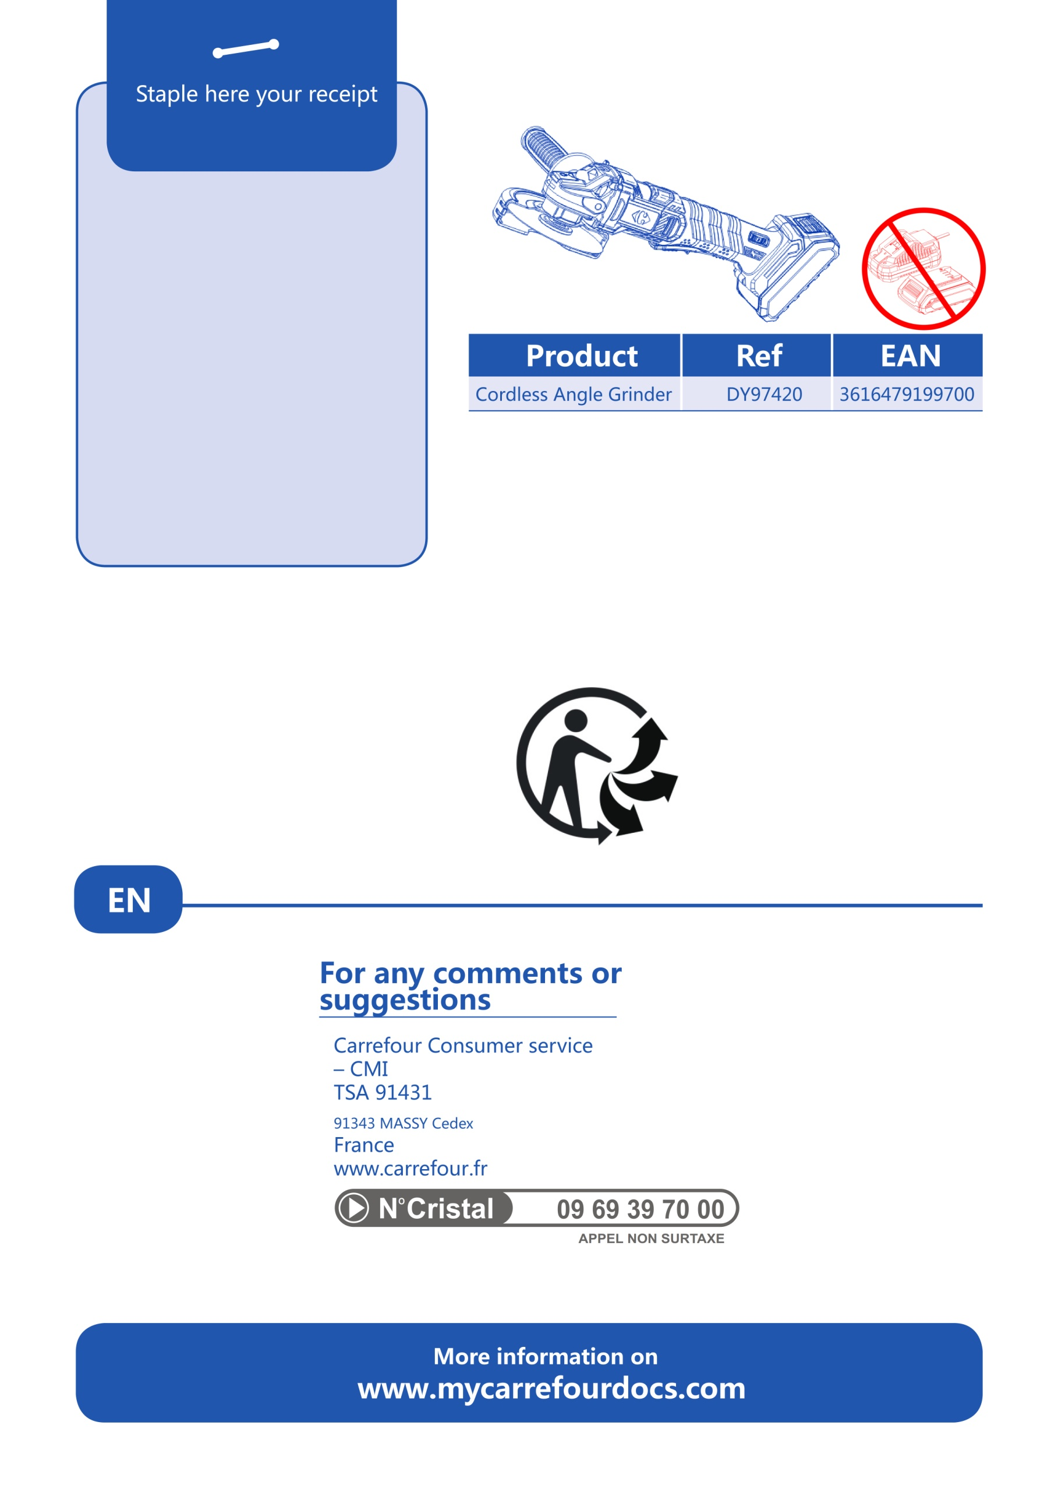

**(DY94287)**